Assignment-11.6:

Find the top five kinds of GoogleKnowlege_Occupation people who were guests in the show, in a particular time period i.e., between '1/11/99' and 6/11/99. You need to write an UDF to compare the dates.

User Defined Function:

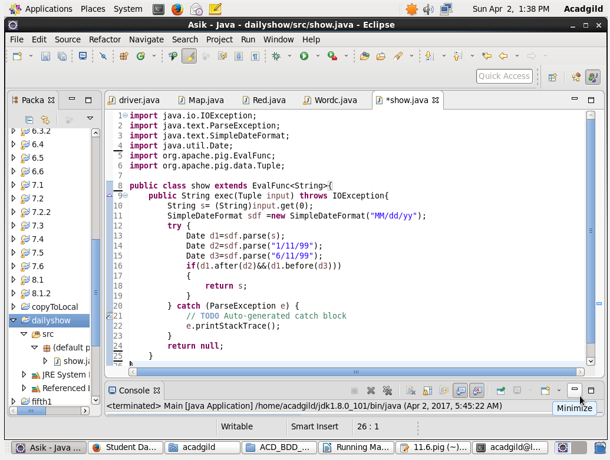

Pig Script:

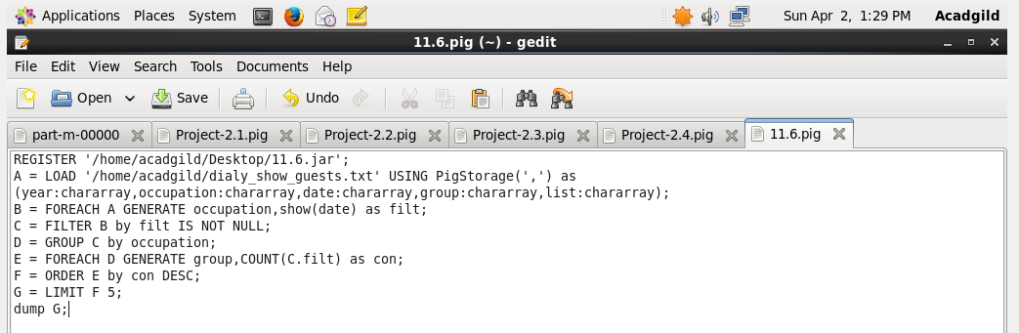

LOGIC:

1.) Filter using the udf function

2.) Filter by not null condition

3.) Grouping by Google occupation

4.) Generating the count for each group

5.) Order and limit by 5 to get the top 5

Running the Script:

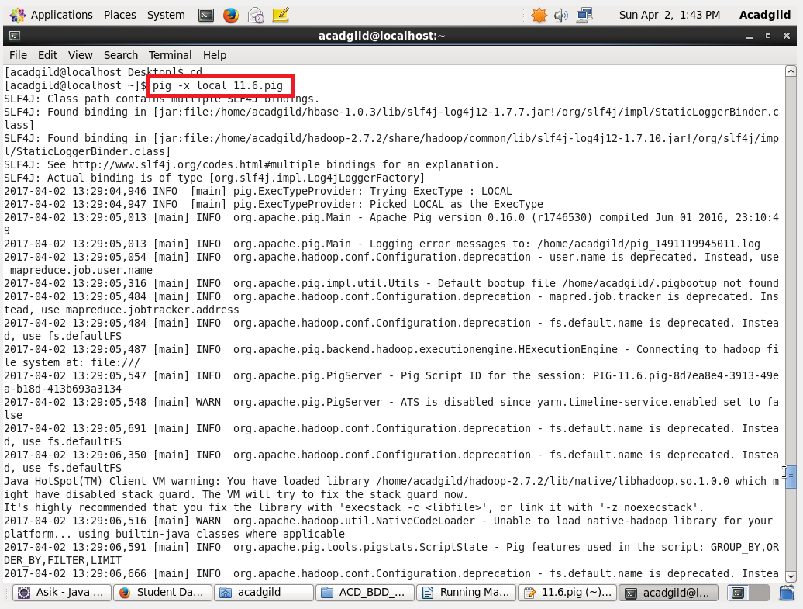

Output:

